**DAILY ONLINE ACTIVITIES SUMMARY**

|  |  |  |  |  |  |  |  |
| --- | --- | --- | --- | --- | --- | --- | --- |
| **Date:** | **26-05-2020** | | | **Name:** | | **B.A.SOHANKUMAR** | |
| **Sem & Sec** | **4TH SEM A** | | | **USN:** | | **4AL18CS013** | |
| **Online Test Summary** | | | | | | | |
| **Subject** | | **DESIGN AND ANALYSIS OF ALGORITHM** | | | | | |
| **Max. Marks** | | **30** | | | **Score** | **24** | |
| **Certification Course Summary** | | | | | | | |
| **Course** | **PYTHON FOR MACHINE LEARNING** | | | | | | |
| **Certificate Provider** | | | **GREAT LEARNING ACADEMY** | | **Duration** | | **5 HOURS** |
| **Coding Challenges** | | | | | | | |
| **Problem Statement:1:Write a program in C to print all permutations of a given strings using pointer.**  **Problem Statement:2:Given an array A of size N where the array elements contains value from 1 to N with the duplicates,the task is to find total number of sub arrays which start and end at the same element.** | | | | | | | |
| **Status:Executed** | | | | | | | |
| **Uploaded the report in Github** | | | | | **YES** | | |
| **If yes Repository name** | | | | | **LOCKDOWN CODING** | | |
| **Uploaded the report in slack** | | | | | **YES** | | |

**ONLINE TEST DETAILS:**

The online test was from module 2 of DESIGN AND ANALYSIS OF ALGORITHM (18CS42).Duration of test is 45 minutes from 9.15am to 10.00am .30 questions of multiple choice.

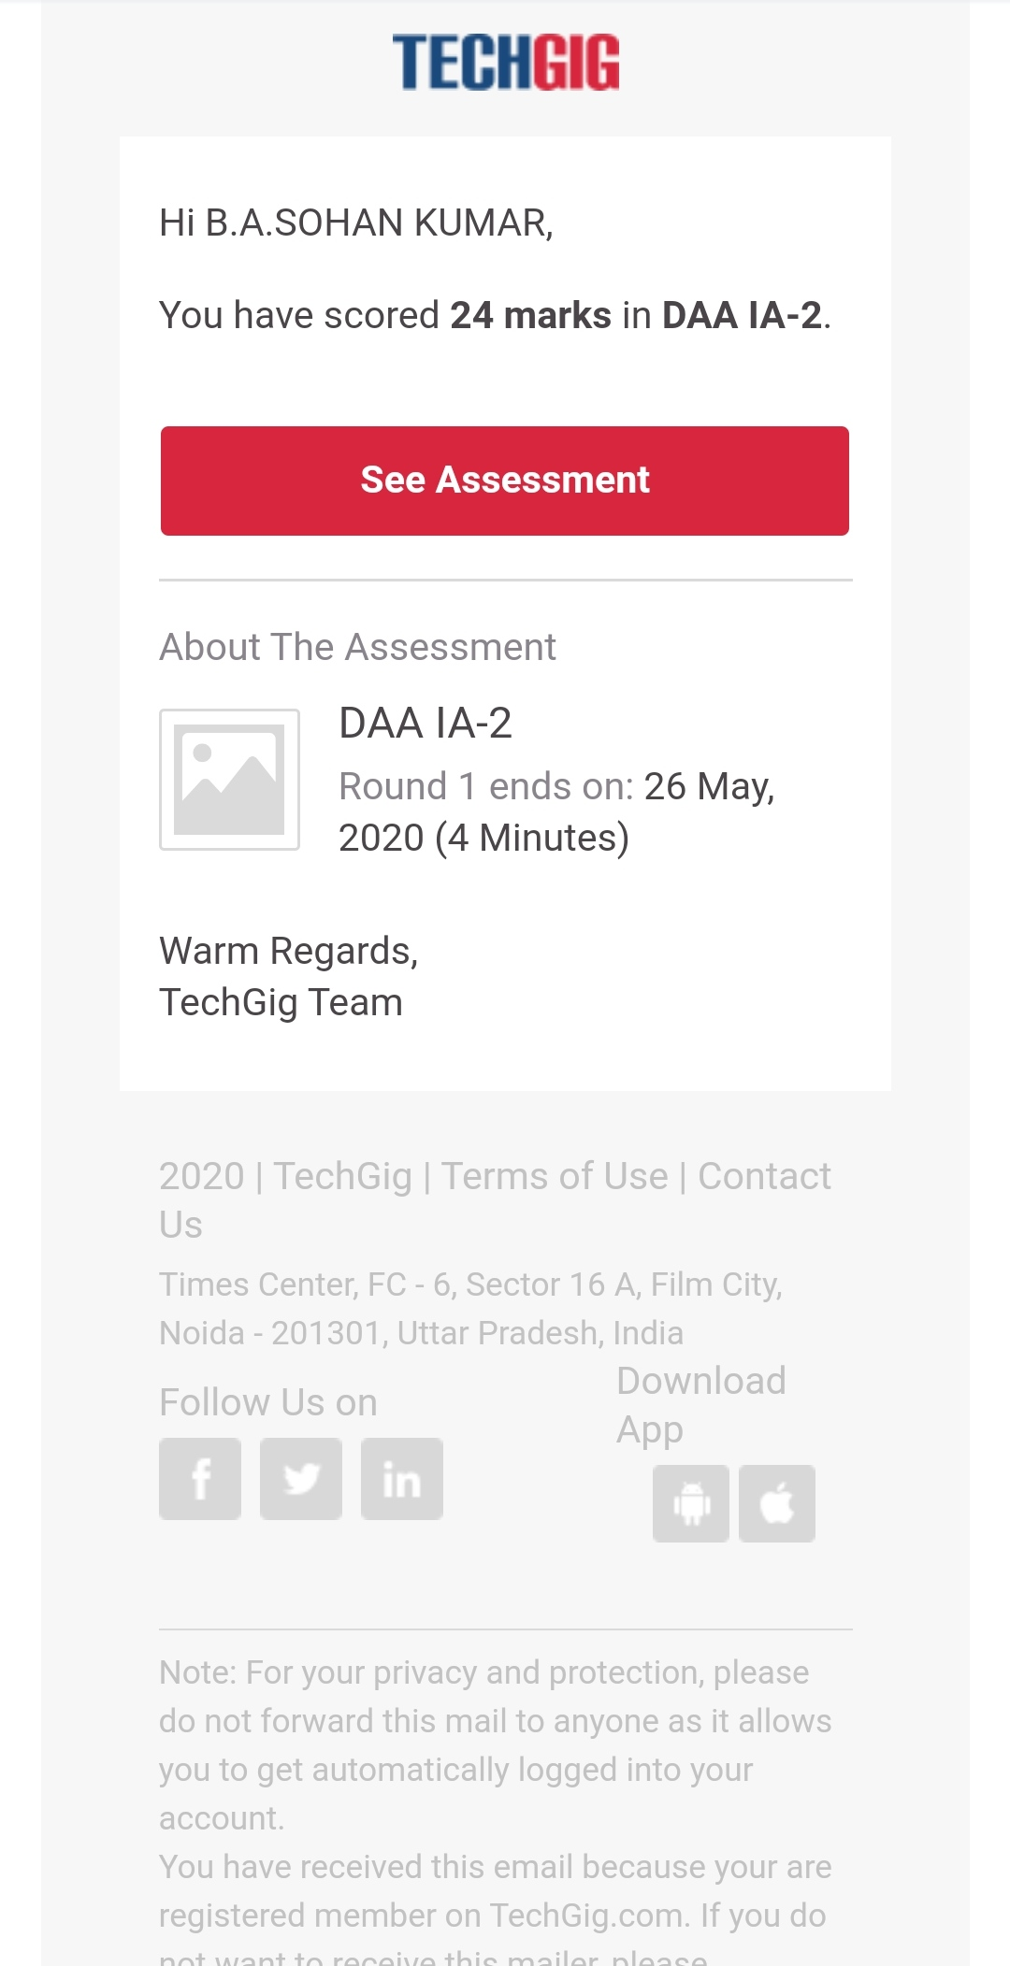

**CERTIFICATION COURSE DETAILS:**

Course:PYTHON FOR MACHINE LEARNING

Today learnt about Pandas -User Defined Functions,Lambda Functions,Classes and Object and completed with the online certification course.Attended the practice assessment and one Assessment quiz.

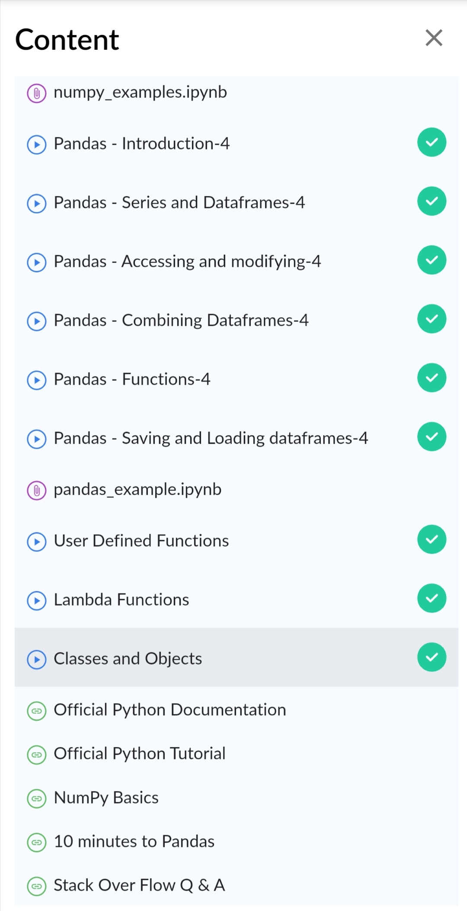

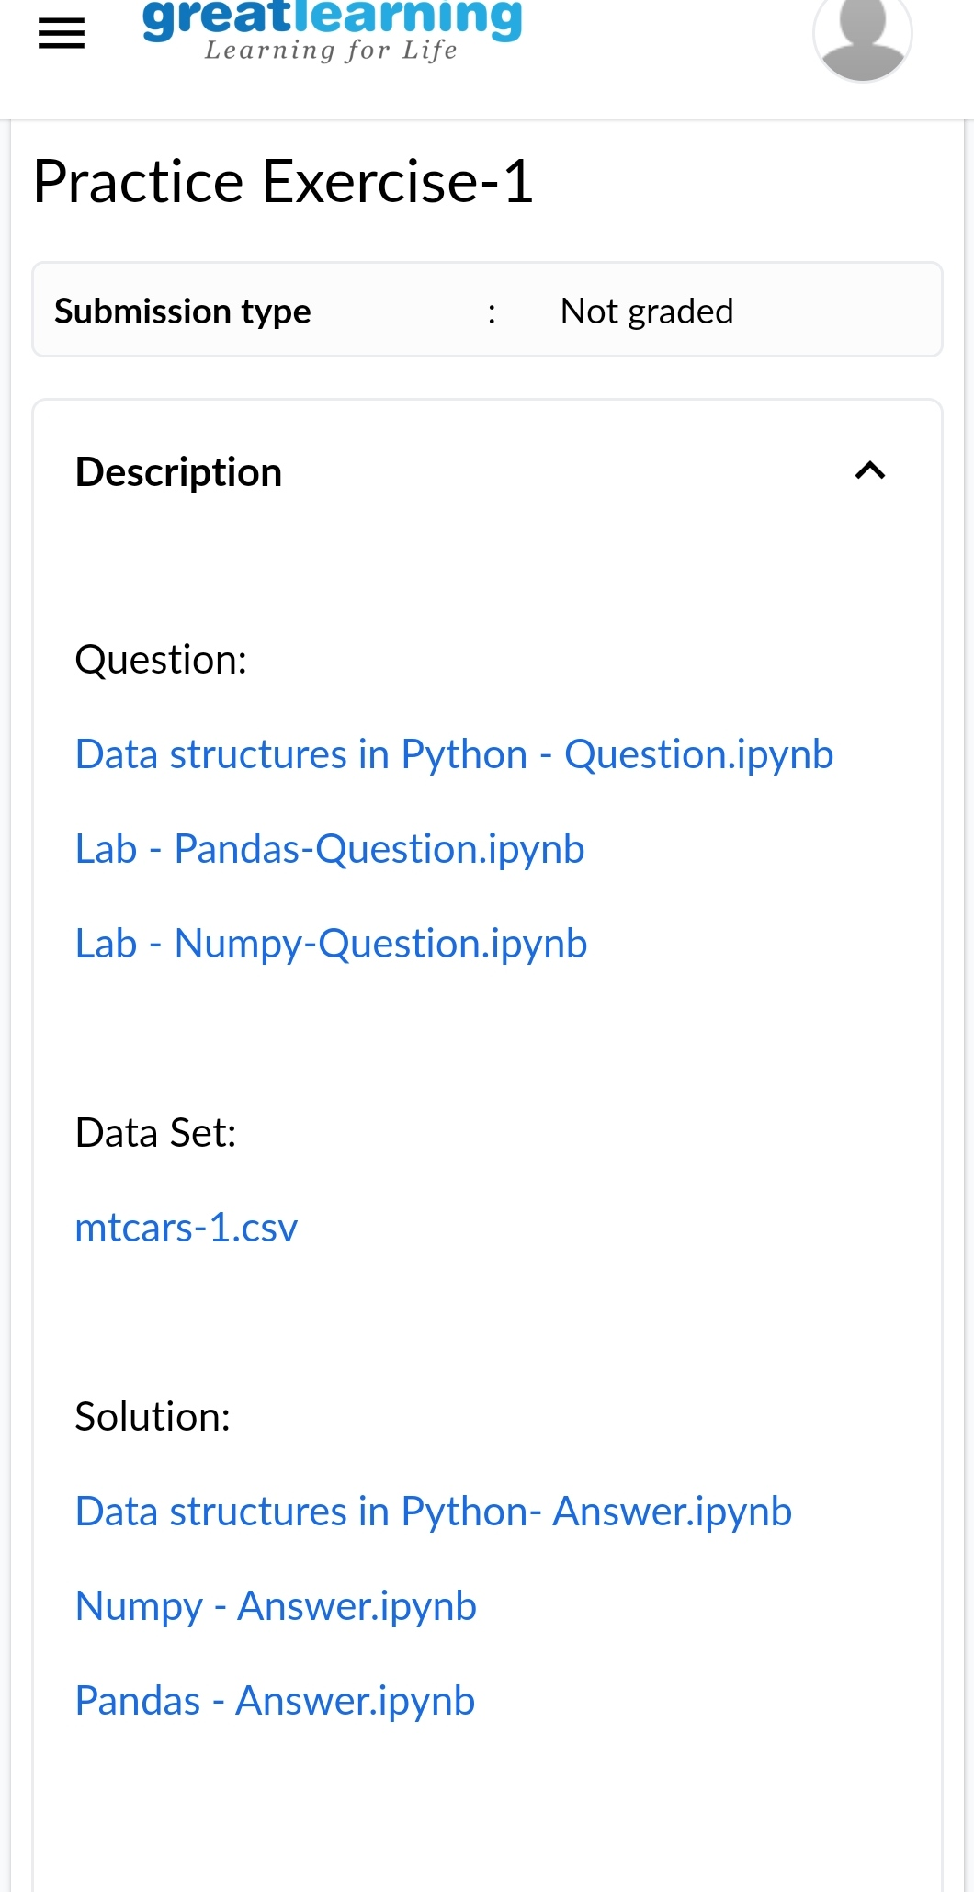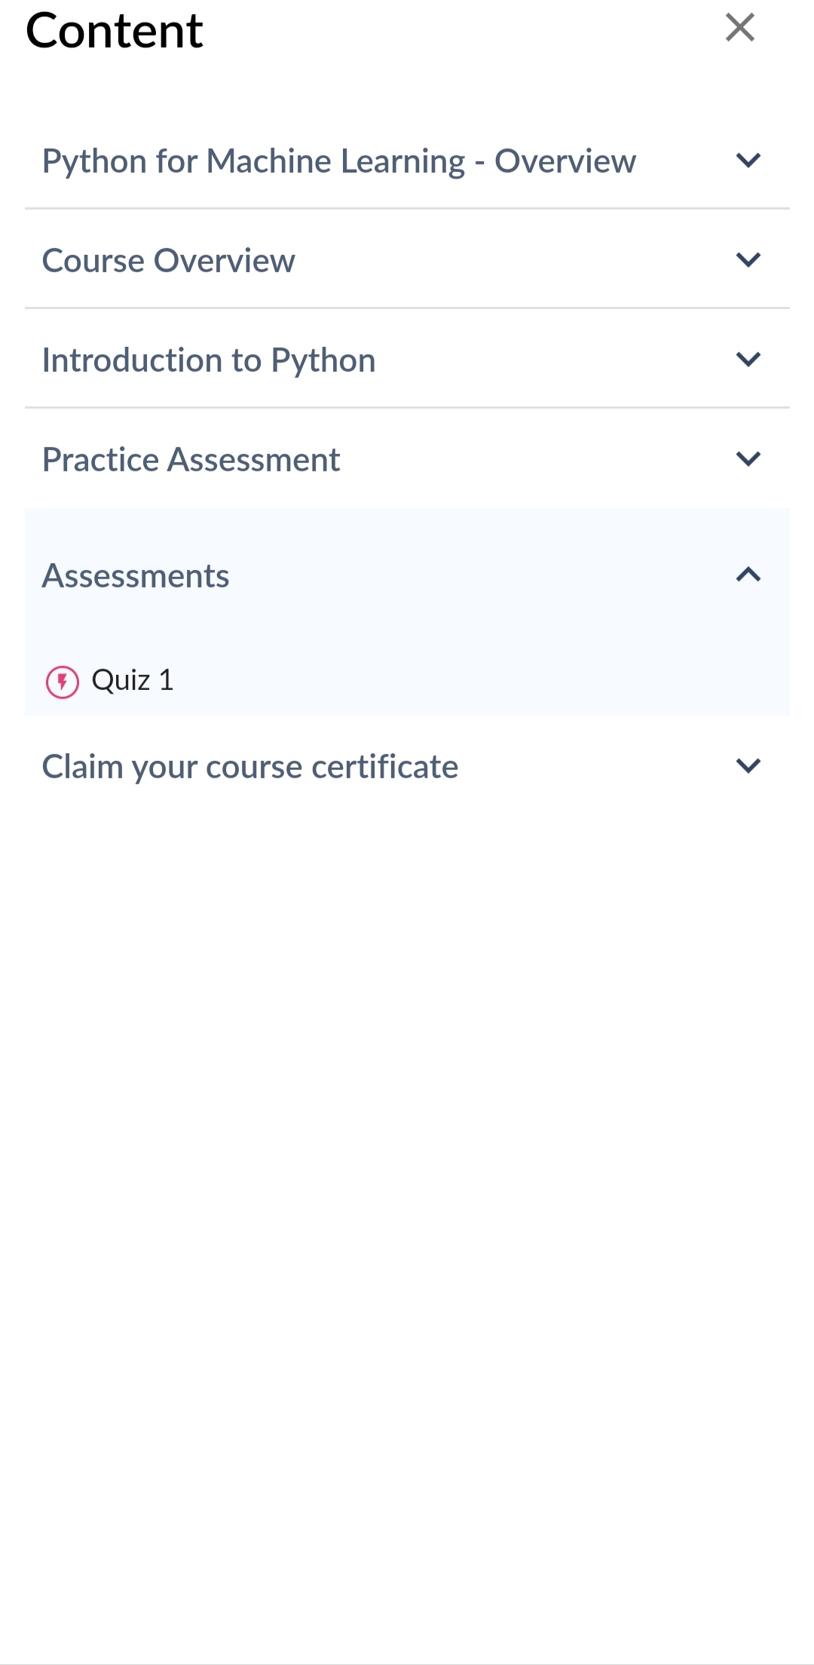

**PRACTICE EXERCISE. QUIZ ASSESSMENT.**

**CODING CHALLENGES:**

1:Write a program in C to print all permutations of a given strings using pointer**.**

Input:Enter the Input String: abcd

The permutations of the string are :abcd abdc acbd acdb adcb adbc bacd badc bcad bcda bdca bdac cbad cbda cabd cadb cdab cdba dbca dbac dcba dcab dacb dabc

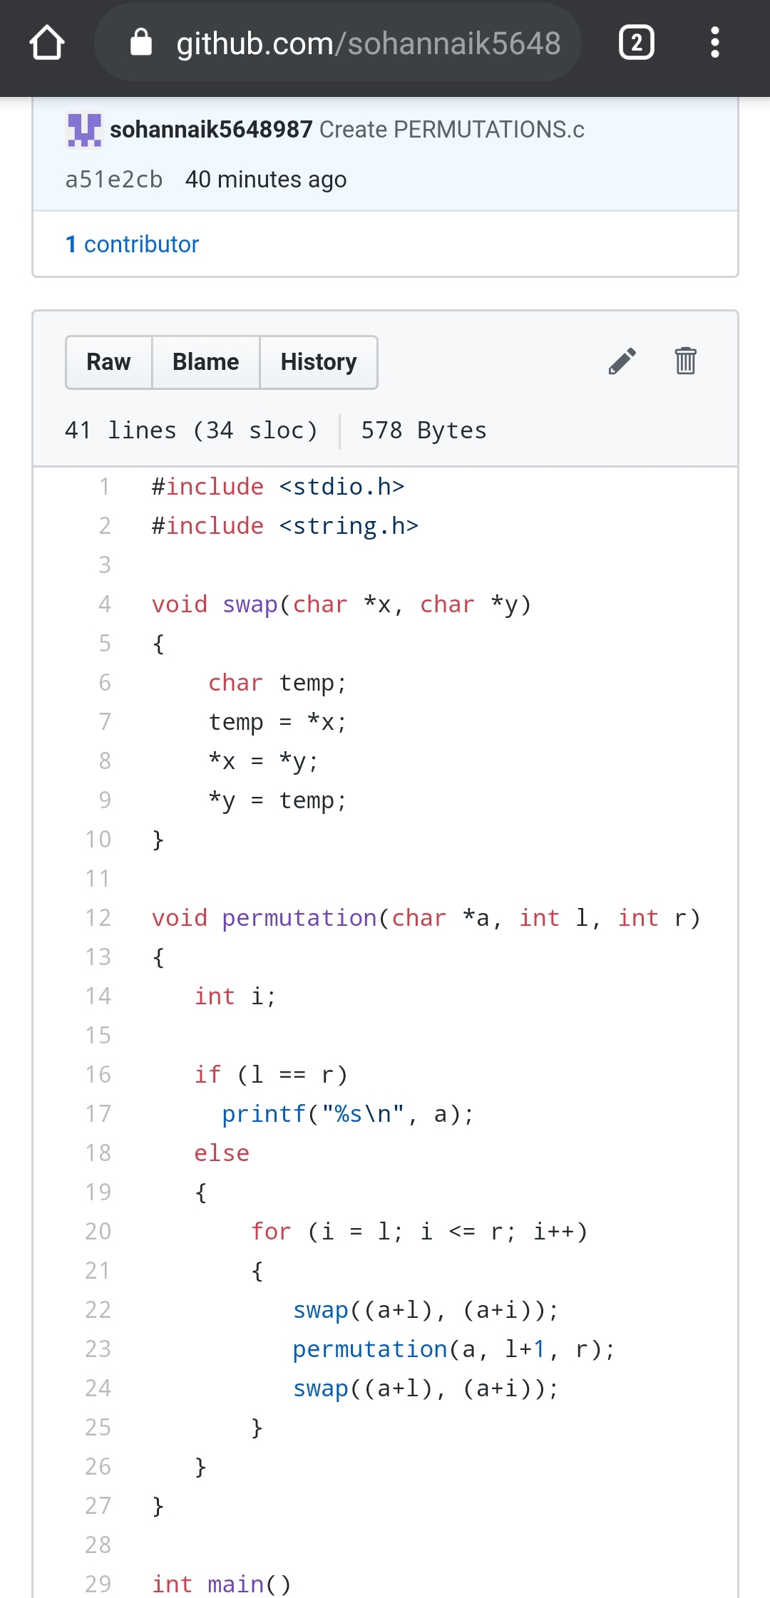

2:Given an array A of size N where the array elements contains value from 1 to N with the duplicates,the task is to find total number of sub arrays which start and end at the same element.

Examples:Input: A[] = {1, 2, 1, 5, 2} Output: 7

Explanation:Total 7 sub-array of the given array are {1}, {2}, {1}, {5}, {2}, {1, 2, 1} and {2, 1, 5, 2} are start and end with same element.

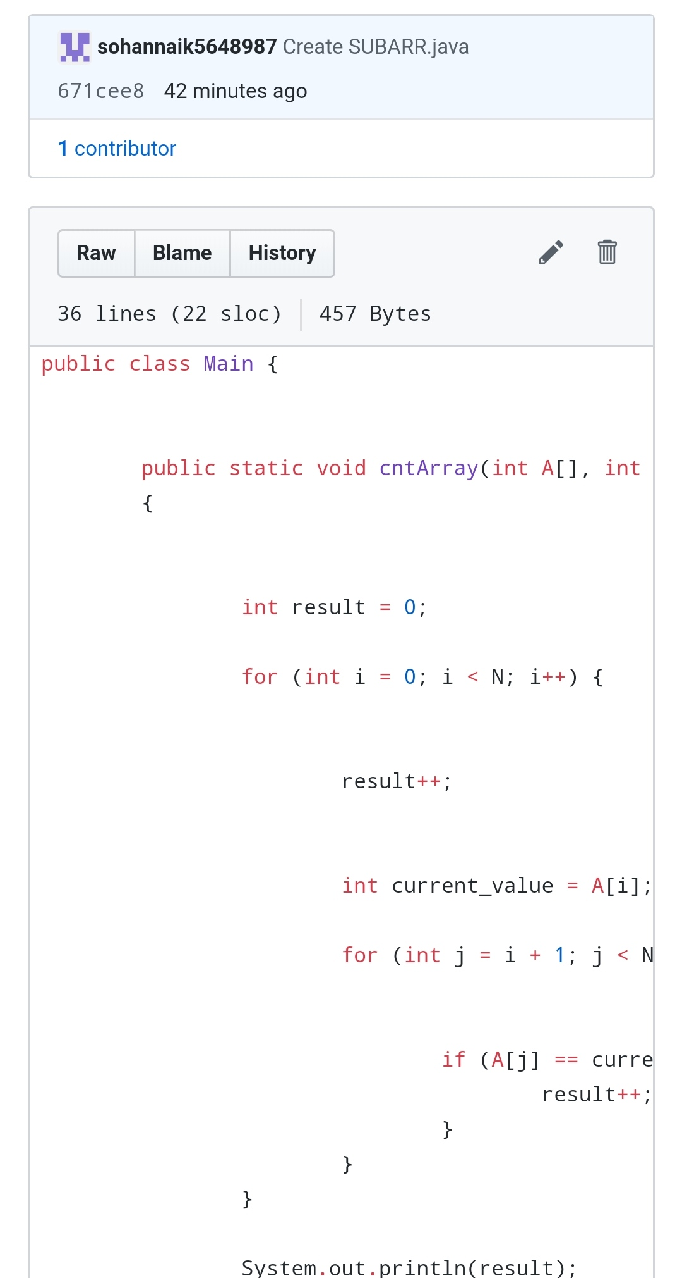

REPOSITORY LINK:1.https://github.com/sohannaik5648987/JAVA-CODING

2.https://github.com/sohannaik5648987/C-CODING